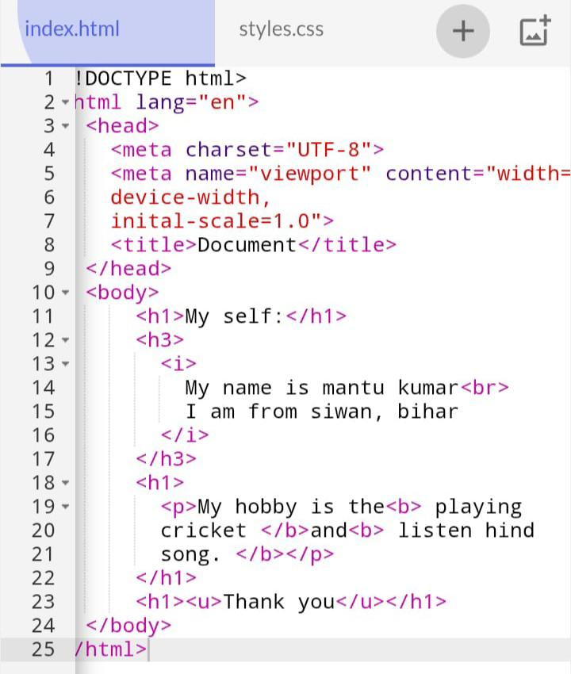
1.create a basic html web page using headings, paragraphs,and text formatting tags.

Output –
